user interface prototype

*<Place your user interface prototypes here. One diagram for one page of your app. You may use online free software or may draw it on a piece of paper with pen, scan/take a photo and add it here. The following diagram is created in Justinmind (*[*http://www.justinmind.com/*](http://www.justinmind.com/)*) You might also check* [*https://www.lucidchart.com/*](https://www.lucidchart.com/) *>*

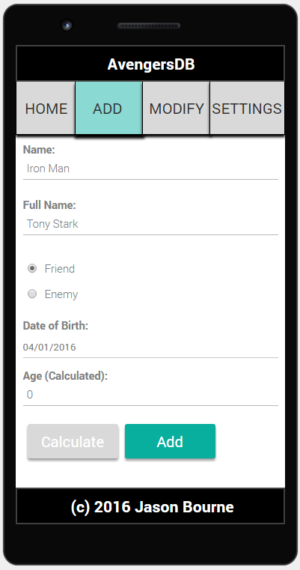

Figure 1: Screen 2- Add a Friend